**STEP 1:**

**DATA SELECTION:**

* An appropriate dataset for credit card fraud detection is given. One commonly used dataset for this purpose is the Credit Card Fraud Detection dataset.
* During data selection, researchers have to define under which circumstances collected data should be stored or discarded.

**STEP 2:**

**IMPORT NECESSARY LIBRARIES**

* In Python, We typically used libraries like Pandas, NumPy, and Scikit-Learn for data manipulation and machine learning. Import these libraries:

**import pandas as pd**

**import numpy as np**

**STEP 3:**

**LOAD THE DATASET**

* Load the dataset into a Pandas DataFrame. Assuming that we downloaded the dataset as a CSV file, you can load it like this:

**df = pd.read_csv('creditcard.csv')**

**STEP 4:**

**DATA EXPLORATION**

* Explore the dataset to get an understanding of its structure. Use functions like `head()`, `info()`, and `describe()` to view the first few rows, data types, and basic statistics:

**print(df.head())**

**print(df.info())**

**print(df.describe())**

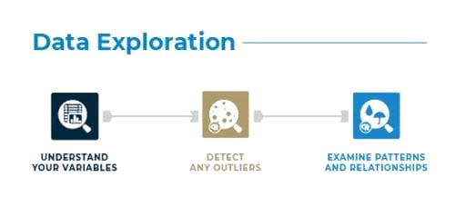

**STEP 5:**

**DATA PREPROCESSING**

* Data preprocessing is crucial for a fraud detection project. This includes handling missing values, scaling features, and addressing class imbalance (since fraud cases are typically rare). Here are some common preprocessing steps:

**Handling Missing Values**:

* Check for missing values and decide whether to impute or drop them.

**Feature Scaling:**

* Standardize or normalize the features, especially if you plan to use algorithms sensitive to feature scales.

**Class Imbalance**:

* Determine if there's a class imbalance issue and consider using techniques like oversampling, undersampling, or synthetic data generation (e.g., SMOTE) to address it.

**Feature Engineering**:

* Create new features if needed, and encode categorical variables.

Here's an example of how to perform some of these preprocessing steps:

**# Handle missing values (if any)**

**df.dropna(inplace=True)**

**# Feature Scaling (standardization)**

**from sklearn.preprocessing import StandardScaler**

**scaler = StandardScaler()**

**df['Amount'] = scaler.fit_transform(df['Amount'].values.reshape(-1, 1))**

**# Class Imbalance (assuming 'Class' is the target variable)**

**fraud_cases = df[df['Class'] == 1]**

**valid_cases = df[df['Class'] == 0]**

**# Implement oversampling or other techniques as needed.**

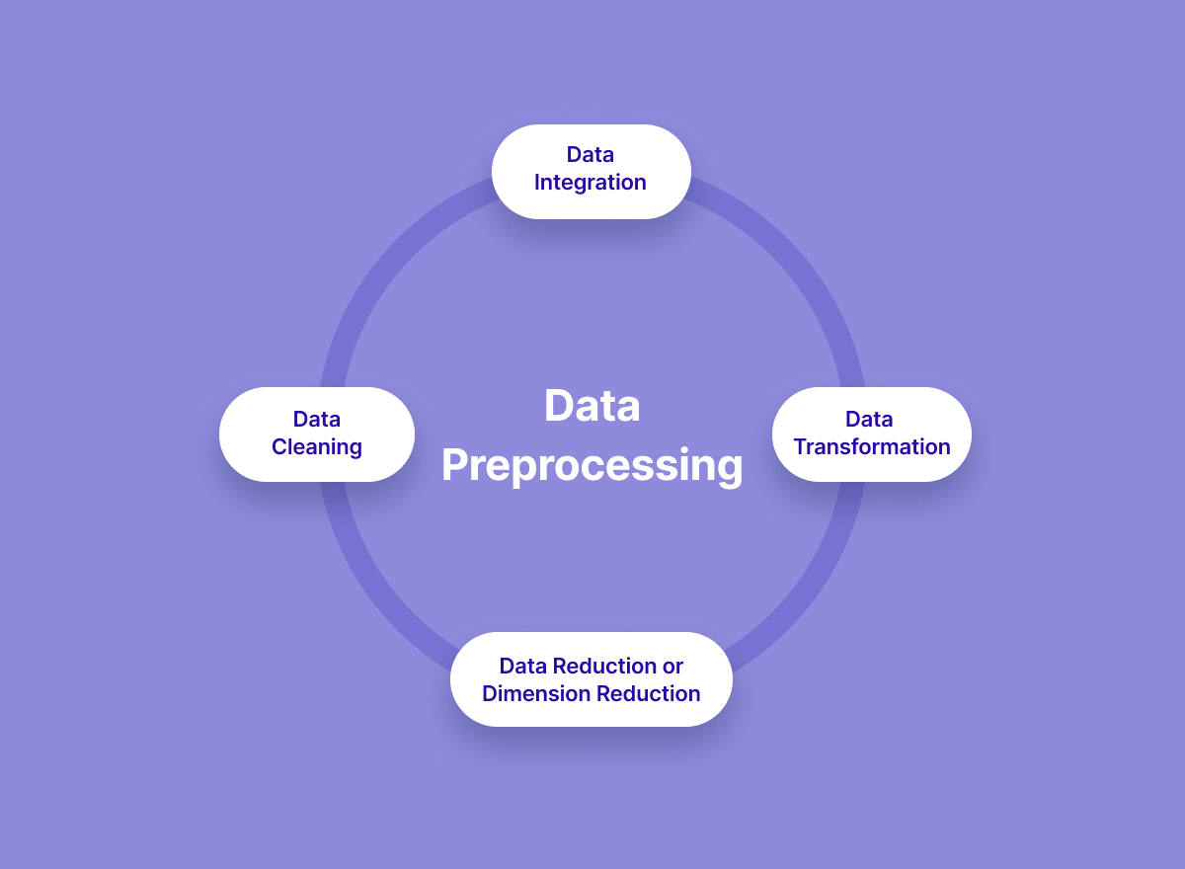

**CONCLUSION:**

* We've completed these steps, we had preprocessed dataset ready for further analysis and model building.